# Implement Web Drivers on Chrome & Firefox Browsers.

WebDriver in Chrome:

Installation Steps:

Step 1: Check the version of Chrome

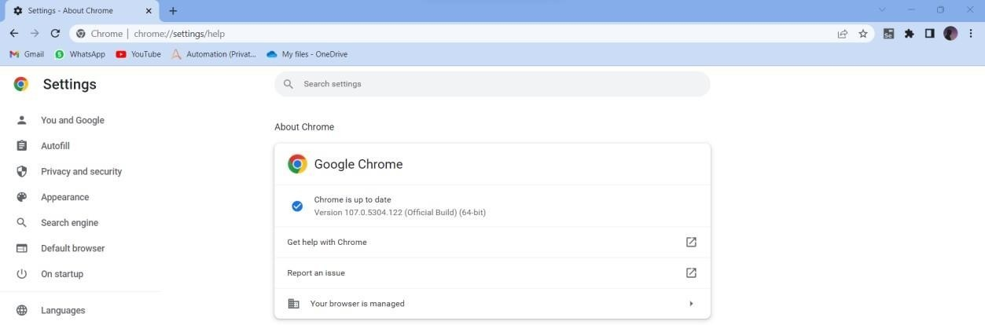

Step2: Search for the Driver in google by giving command “selenium driver forchrome”

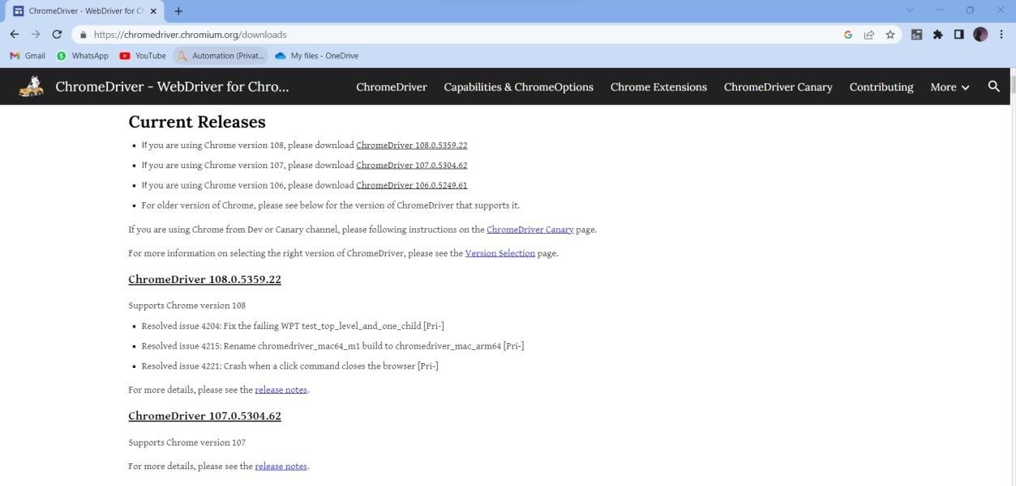

Step3: Click on Respective version and Download the zip file and Create the Separatefolder of the name driver and extract the zip file in that folder

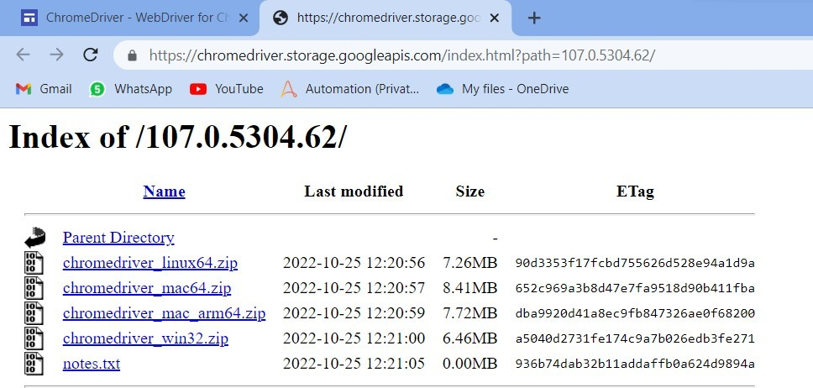

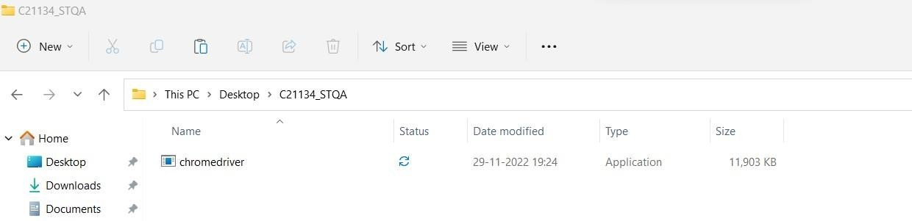

Step 4: Download the jar file by typing the following query “selenium jar files download” , Zip file will be downloaded extract the zip file in the Separate dedicated folder.

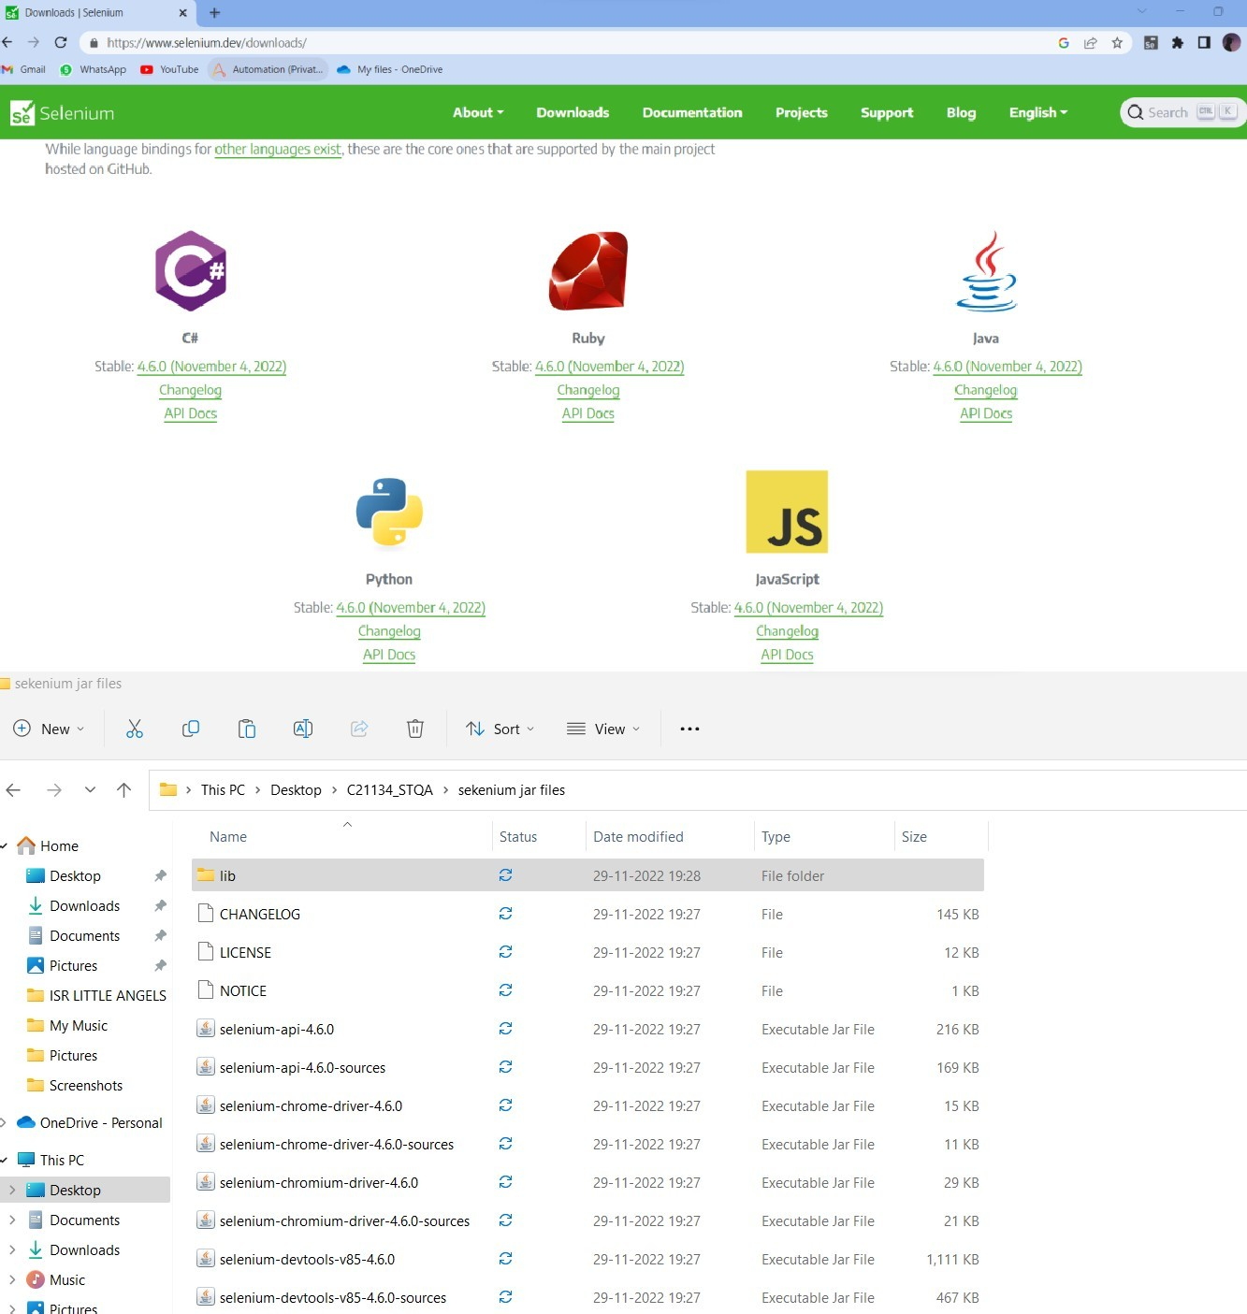

Step 5: Install Eclipse if not there

Step 6: Open Eclipse and create a java Project, give the project name, Creat a package in that Project Give a package name, Create a Class give a name to the class

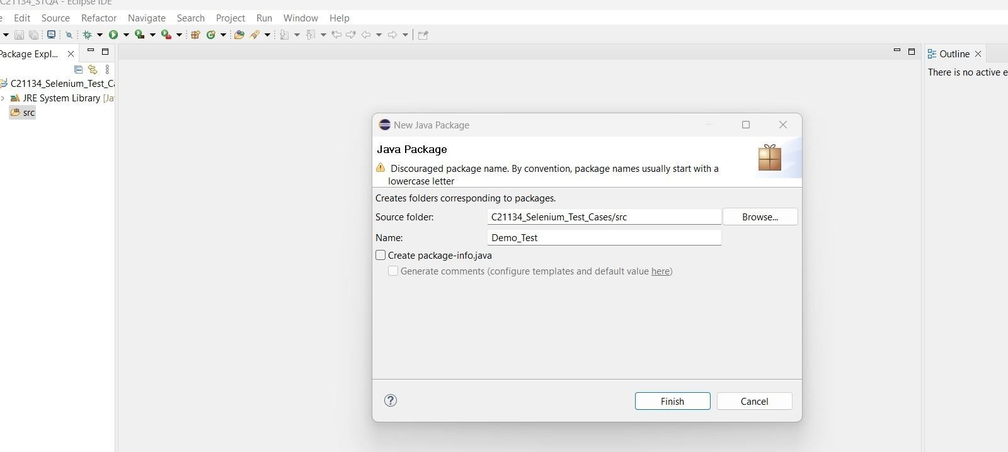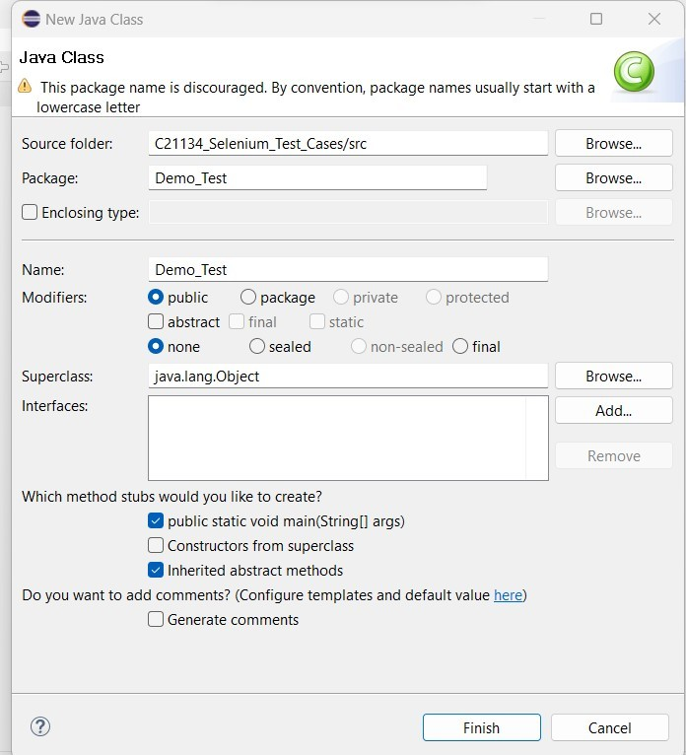

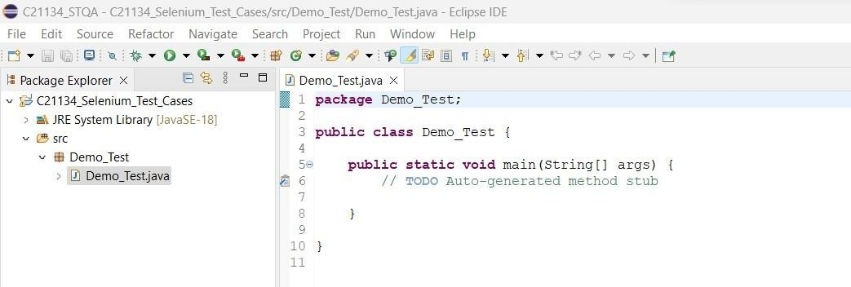

Step7: Import the jar file of selenium in eclipse, Right click on project goto properties, Gotojava build path, Goto Libraries, Click on Classpath , Click on add External jar

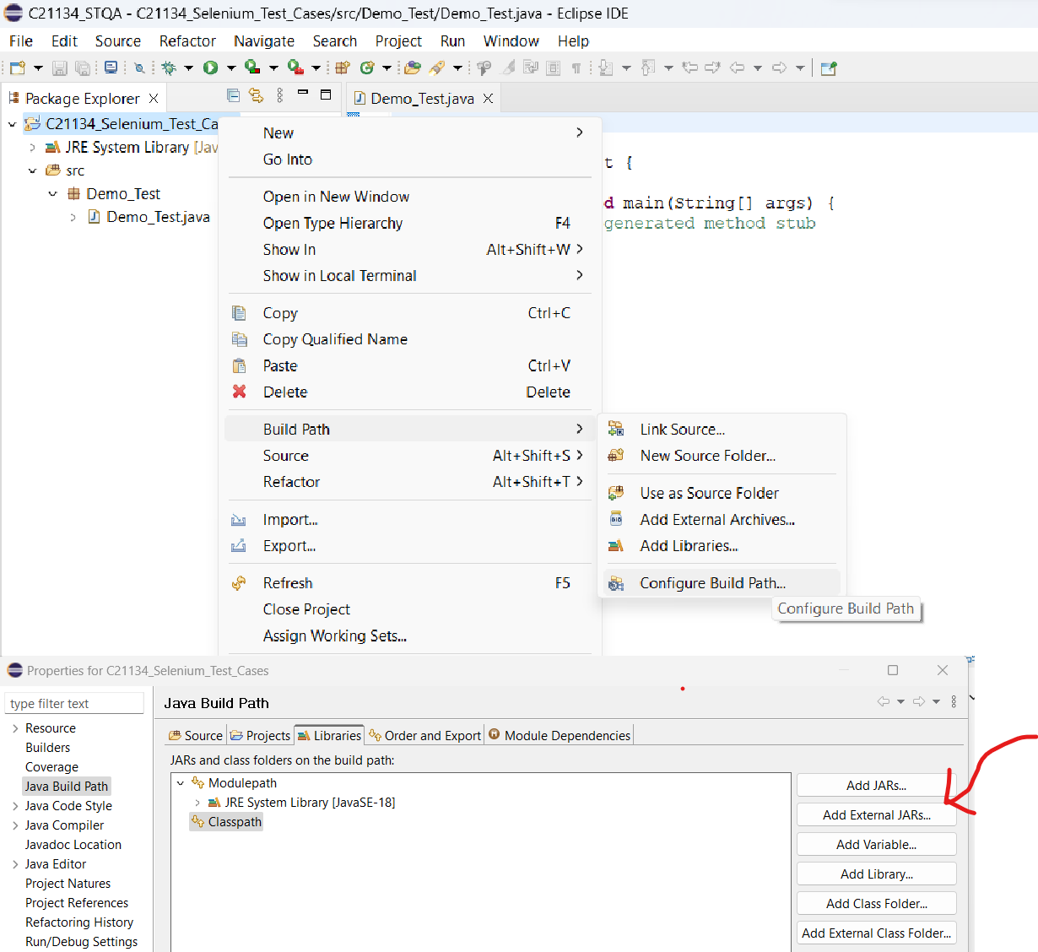

Step 8: Select all the jar files inside of lib folder too

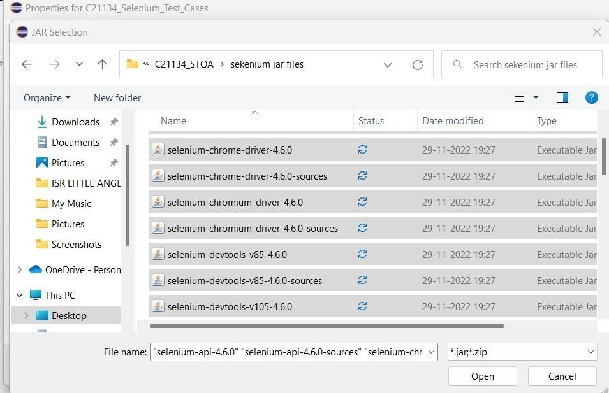

Step 9: Setup is ready know check the basic program for driver Code:

package TestCases;

import org.openqa.selenium.WebDriver;

import org.openqa.selenium.chrome.ChromeDriver; public class First_Test

{

public static void main(String[] args)

{

System.setProperty(“Webdriver.chrome.driver”,”C:\\Users\\Sayali\\On eDrive\\Desktop\\C22096_STQA\\chromedriver.exe”);\\chromedriver.exe"

}

}

Output :

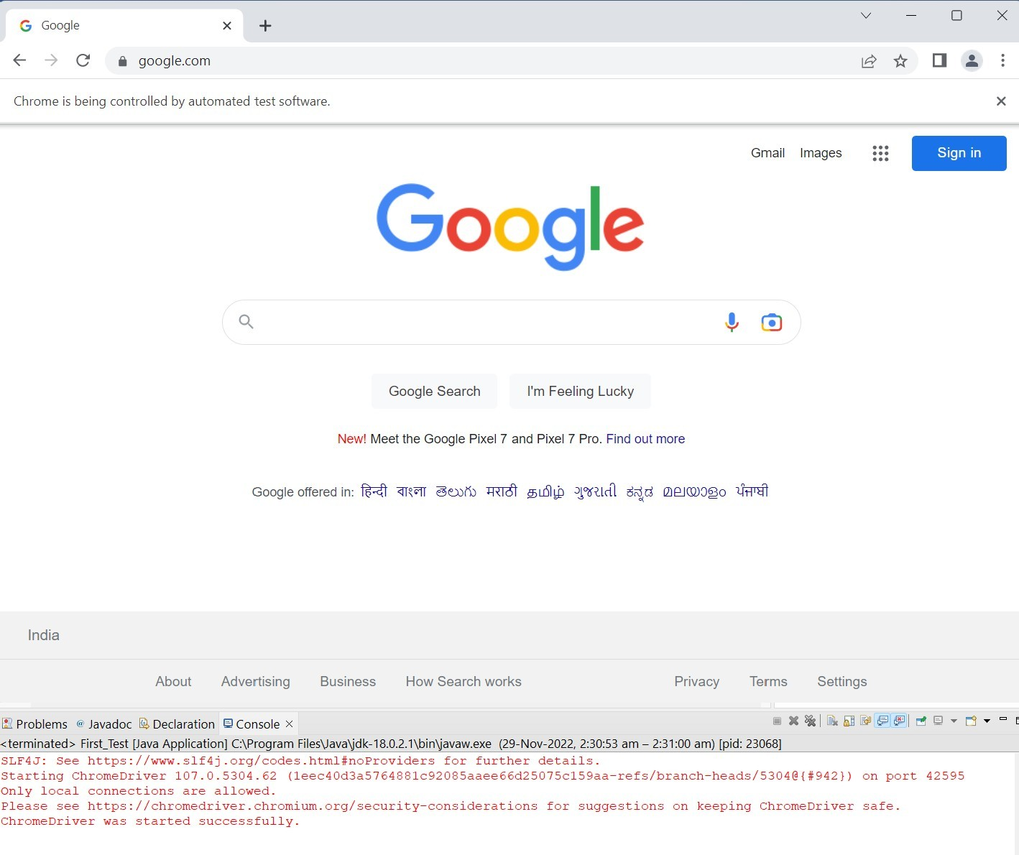

# WebDriver in Firefox:

Step 1. the zip file of diver click on link https://github.com/mozilla/geckodriver/releases and download it and Extract the zip file and save it to the Divers folder

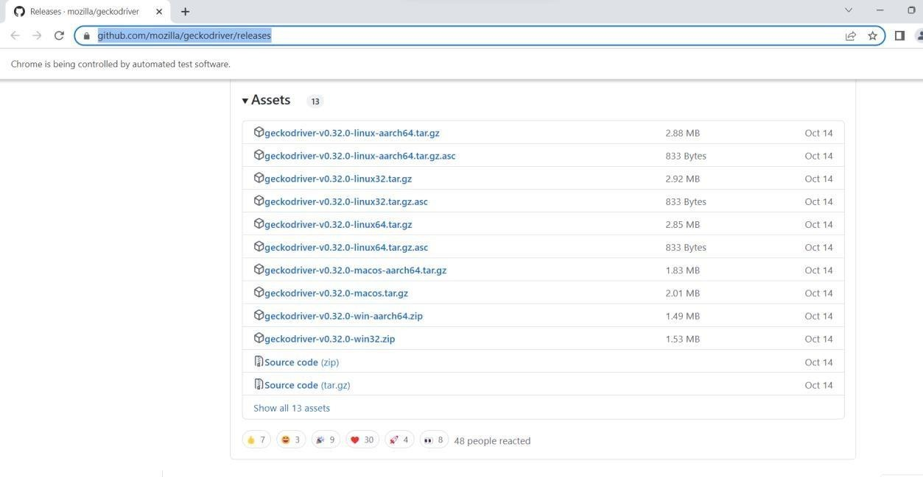

Repeat the same steps from step 4 to step 8

Step 9: Setup is ready know check the basic program for driver package TestCases;

import org.openqa.selenium.WebDriver;

import org.openqa.selenium.firefox.FirefoxDriver; public class Fire_1

{

public static void main(String[] args)

{

System.setProperty("Webdriver.gecko.driver", "C:\\STQA\\Drivers\\geckodriver.exe");

WebDriver driver = new FirefoxDriver(); driver.get("https://[www.google.com/](http://www.google.com/)"); String title =

driver.getTitle(); System.out.println("The title is "+title);

}

}

Output :

